**Experiment No. 1.4**

1. **Aim/Overview of the practical:**

Create a webpage and publish on Azure using GitHub and VS Code.

1. **Code for practical:**

* Create a file using HTML, CSS and JS in VS Code Editor or any other IDE or Text Editor.
* Open GitHub for desktop and Go to file > New Repository.

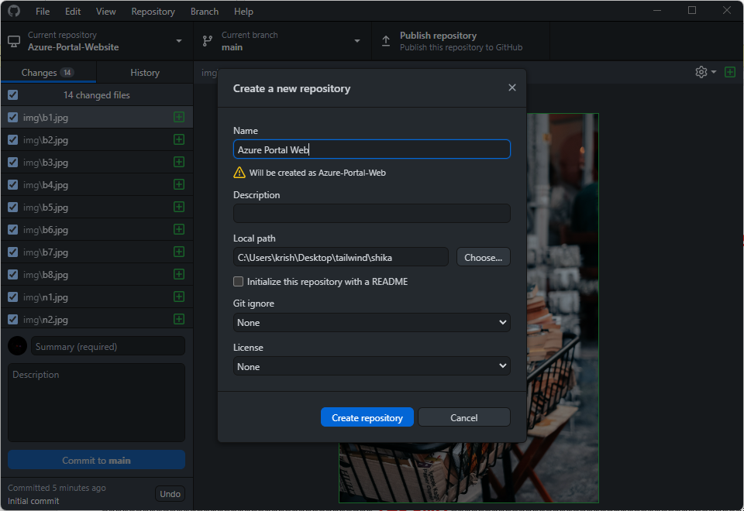

* Provide a name of your repository and select the path of your website code.
* Then click on “***Create Repository”*** button.
* A new folder will create with that name in your selected path and move all your code files to that folder.

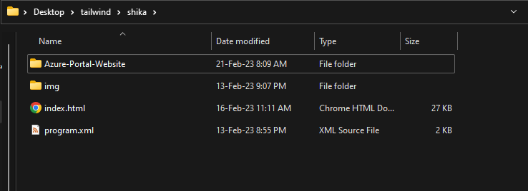

* After moving your files, Right click and Click on Open with code button.
* Navigate to Source Control and type “***Initial Commit***” to commit your code.

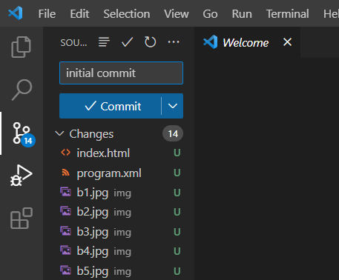

* Open your GitHub and click on Publish Repository.

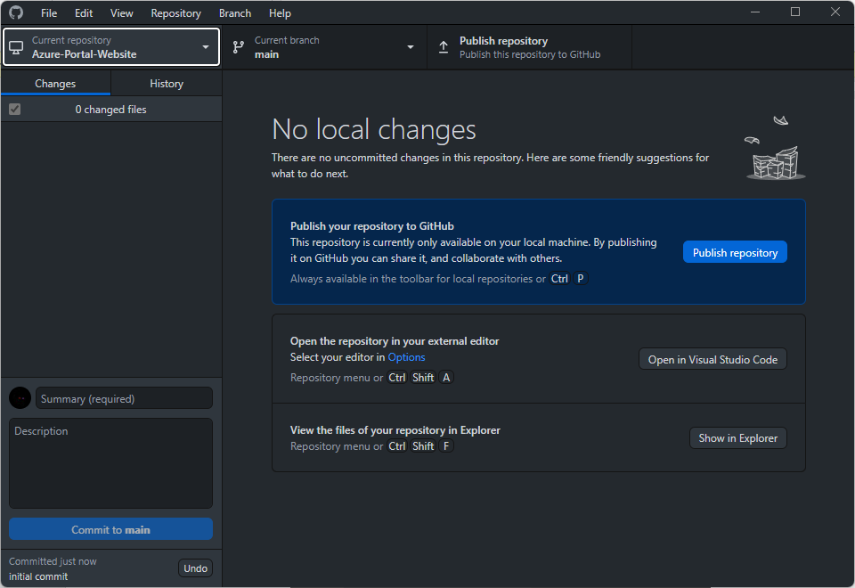

* Now open Azure Portal and click on “***Create Static WebApp”***. Provide Name and Select plan for WebApp.
* Now click on GitHub and select your repository.

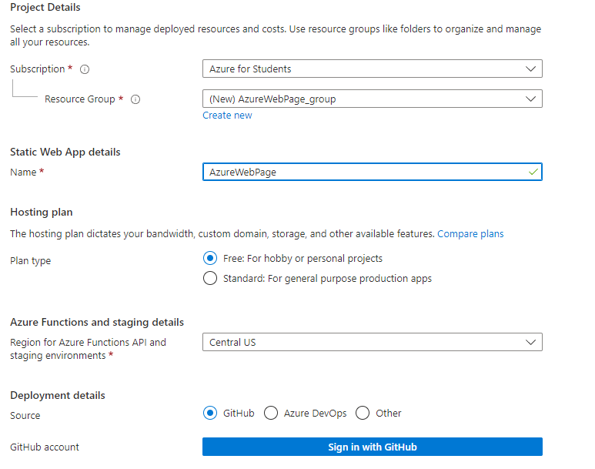

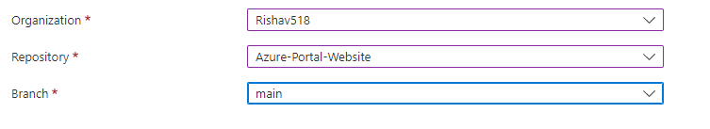

* Click on “***Review + Create”*** button to deploy your WebApp.

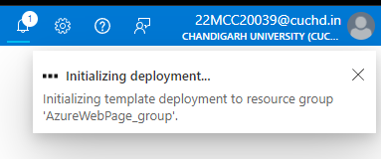

* It’ll take a minute or two to deploy your website.

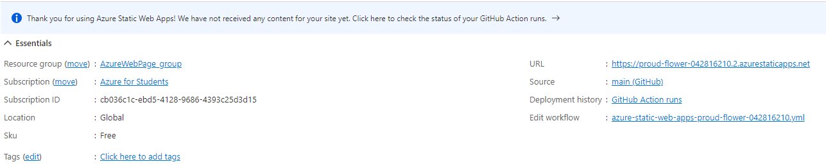

* Click on ***Browse*** button or click on URL to view your deployed website.

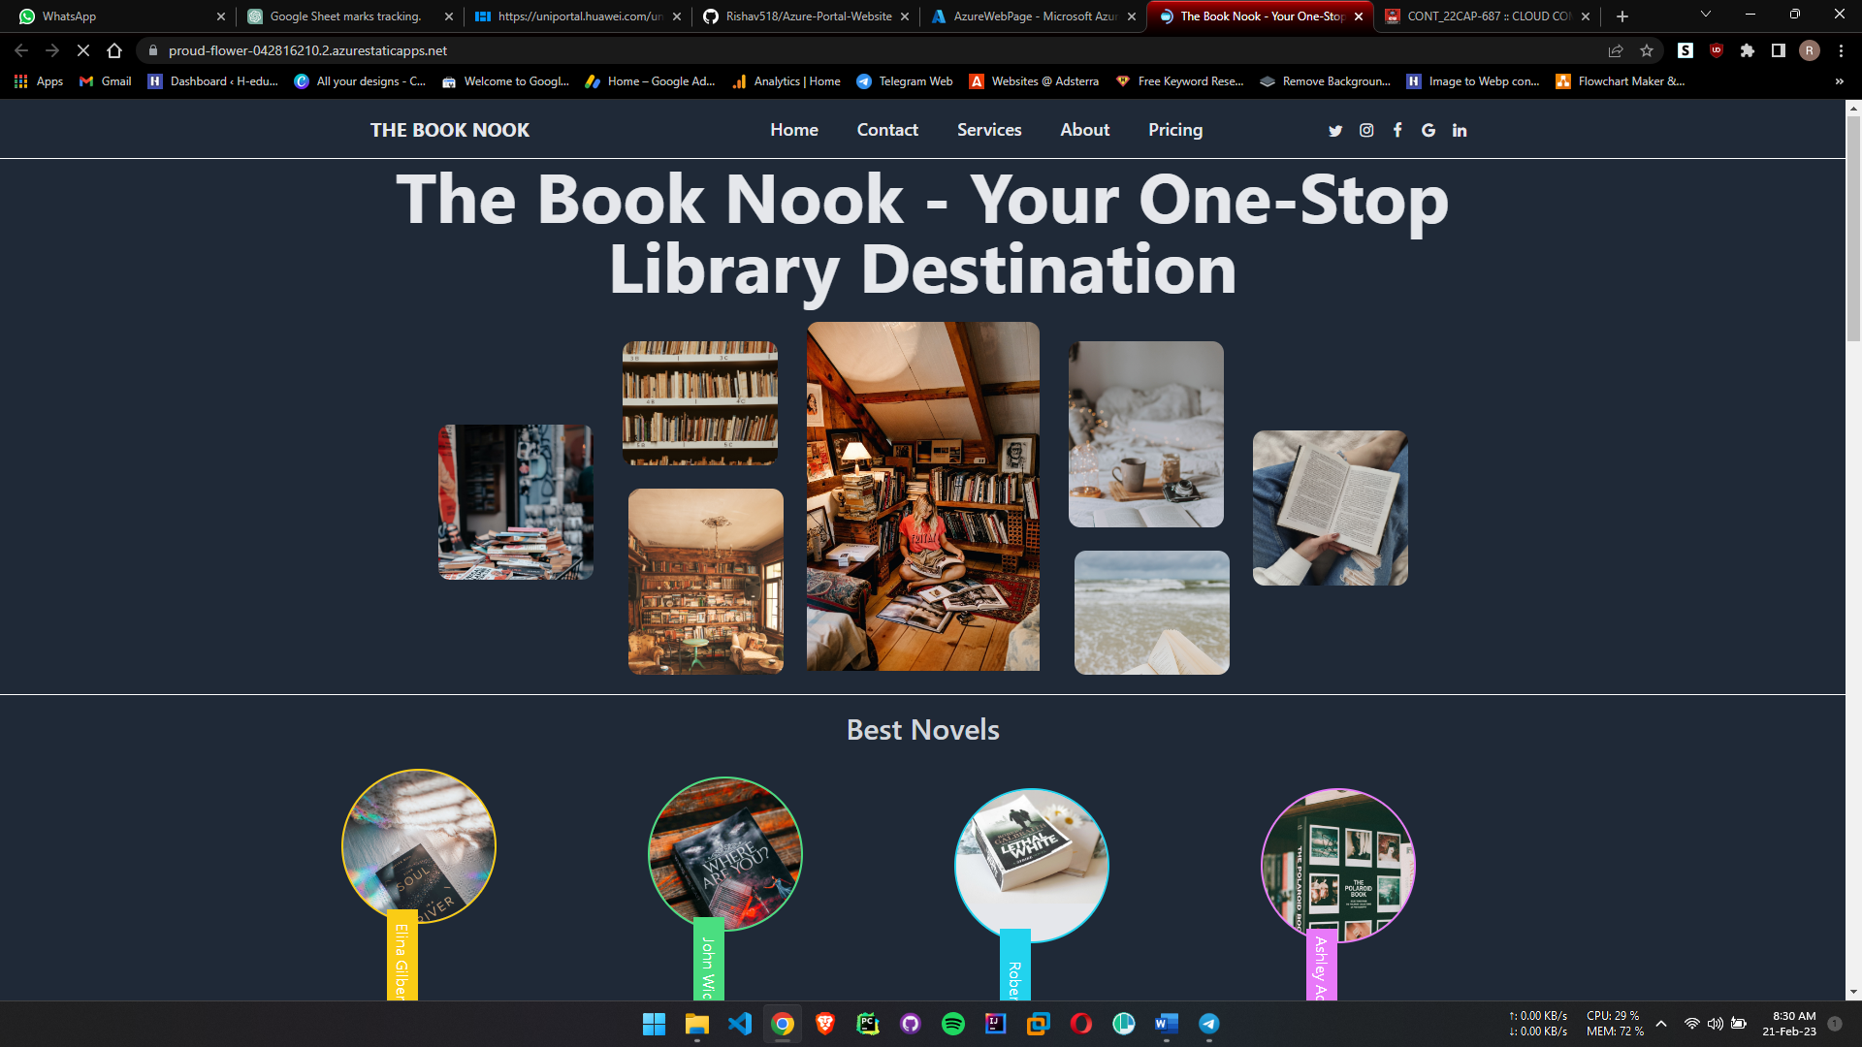

**************************************** **THE END** ***********************************************